Guidelines for Salesforce Developer Project Documentation And Demo Video Presentationsss

User Story:
As a Salesforce Admin, I want to create a comprehensive player performance tracking application within Salesforce to capture and analyze detailed match-by-match information of cricket players. This application will include custom objects such as Player and Match Performance with carefully defined fields and relationships to ensure data integrity and accessibility. By leveraging master-detail and lookup relationships, the application will enable robust tracking of individual and team performances, facilitate insightful reporting and analytics, and support the overall management of player statistics, thereby enhancing strategic decision-making and player development initiatives.

1. INTRODUCTION
1.1 Project Overview :
CRICKSTATS is a Salesforce-based application designed to track, manage, and analyze cricket players’ performance on a match-by-match basis. The system uses custom objects, relationships, dashboards, and automation tools to provide structured performance insights.It enables coaches, analysts, and administrators to record player statistics, generate reports, and support strategic decision-making.

1.2 Purpose :

The main purpose of this project is:
To digitize player performance records
To improve accuracy and accessibility of cricket statistics
To provide real-time analytics
To support player development and team planning
To automate data management using Salesforce

2. IDEATION PHASE
2.1 Problem Statement (Customer Problem Statement Template)

Problem Statement (PS) | I am (Customer) | I’m trying to | But | Because | Which makes me feel
PS-1 | A cricket team coach | Track player performance across matches | I cannot get accurate statistics easily | Data is stored in different files and formats | Frustrated and unsure about team selection
PS-2 | A team manager | Maintain complete player records | It takes too much time to update and verify data | Most records are maintained manually | Stressed and inefficient
PS-3 | A sports analyst | Analyze player trends and generate reports | I face difficulty in comparing performances | There is no centralized analytics system | Confused and dissatisfied

2.2 Empathy Map Canvas
Target Users
- Team Managers
- Coaches
- Analysts
- Salesforce Admins

Empathy Analysis
Aspect Description
- Think & Feel: Need accurate data, better insights
- Hear: Feedback from management
- See: Multiple data sources
- Say & Do: Collect statistics manually
- Pain: Data errors, delays
- Gain: Faster decisions, automation

2.3 Brainstorming
Brainstormed Ideas
- Web-based player management system
- Mobile statistics tracker
- Salesforce-integrated CRM
- AI-based performance prediction
- Dashboard-based analytics

3.REQUIREMENT ANALYSIS PHASE

3.1 Customer Journey Map
Journey Stages:
- Login
- Enter Player Data
- Record Match Performance
- Generate Reports
- Analyze Results
- Decision Making

3.2 Solution Requirements
Functional Requirements

FR No | Requirement
FR-1 | Player Registration
FR-2 | Match Performance Entry
FR-3 | Dashboard Generation
FR-4 | Report Creation
FR-5 | Flow Automation

Non-Functional Requirements (NFRs) – CRICKSTATS
NFR-1: Usability
The system should be easy to understand and use by coaches, managers, analysts, and
admins without requiring technical training.
Requirements
- Simple and intuitive user interface
- Clear navigation menus
- Easy-to-read dashboards
- Minimal learning curve
Examples:
- A new coach should be able to:
- Log in
- Enter match data
- View player reports
- within a few minutes without special training.

NFR-2: Security
The system must protect sensitive player data from unauthorized access.
Requirements
- Role-based access control
- Secure authentication
- Encrypted data storage
- Regular backups
Examples:
- Coaches can view player statistics
- Managers can edit records
- Analysts can generate reports
- Only admins can modify system settings
Example: Salesforce Profiles and Permission Sets restrict access to confidential information.

NFR-3: Reliability
The system should function correctly without failure and store data accurately.
Requirements
- No data loss
- Automatic backups
- Error handling
- System stability
Example:
If a manager enters match statistics and loses internet connection, the data should be saved automatically when reconnected.Salesforce cloud backup ensures recovery in case of system failure.

NFR-4: Performance
The system should respond quickly and handle large volumes of data efficiently.
Requirements
- Fast page loading
- Quick report generation
- Smooth dashboard rendering
- Minimal response time
Example:
When an analyst generates a performance report for 100+ players, the report should load within 2–3 seconds.Optimized Salesforce queries and caching improve response speed.
NFR-5: Availability
The system should be accessible whenever users need it.
Requirements
- 24/7 system availability
- Minimal downtime
- Cloud-based access
- Disaster recovery
Example:
Coaches should be able to access CRICKSTATS even during tournaments at night or on weekends.Salesforce provides high uptime with cloud hosting.
NFR-6: Scalability
The system should support increasing numbers of users, players, and records.
Requirements
- Handle growing datasets
- Support more teams and leagues
- Expand storage capacity,Maintain performance under load
Example:
If CRICKSTATS is extended from one team to 50 teams, the system should still perform smoothly.Salesforce cloud infrastructure automatically scales storage and processing.

3.3 Data Flow Diagram
Data Flow
User → Salesforce UI → Player Object → Match Performance → Reports → Dashboard

3.4 Technology Stack
Layer | Technology
Frontend | Salesforce Lightning
Analytics | Reports & Dashboards
Automation | Salesforce Flows
Backend | Salesforce Objects
Database | Salesforce Cloud

4. PROJECT DESIGN PHASE

4.1 Problem–Solution Fit
The CRICKSTATS system effectively addresses the key challenges faced in traditional cricket performance management. Earlier, most player and match data were maintained using manual records, which were time-consuming and prone to errors. This issue has been resolved by implementing an automated system through Salesforce, which ensures accurate and efficient data entry and management. The problem of data loss, caused by improper storage and lack of backups, is overcome by using secure cloud storage that safely stores all information and allows easy retrieval. Poor analysis of player performance, due to scattered and unorganized data, is addressed through interactive dashboards that present clear visual insights and reports.

4.2 Proposed Solution
Description
CRICKSTATS provides:
- Custom objects (Player, Match Performance)
- Master-detail relationships
- Roll-up summaries
- Lightning App
- Automated flows
- Interactive dashboards

Key Features

Centralized database

Live statistics

Secure access

Scalable design

Easy reporting

4.3 Solution Architecture
Architecture Layers
- Presentation Layer (Lightning UI)
- Application Layer (Flows, Logic)
- Data Layer (Objects)
- Analytics Layer (Reports)

5. PROJECT PLANNING & SCHEDULING

5.1 Project Planning
- Agile-based execution
- Object creation → automation → reporting
- Sprint-wise development
Product Backlog, Sprint Schedule, and Estimation (4 Marks)
Use the below template to create product backlog and sprint schedule
Sprint | Functional Requirement (Epic) | User Story Number | User Story / Task | Story Points | Priority | Team Members
Sprint-1 | Developer Setup | USN-1 | As an admin, I want to create a Salesforce developer account so that I can configure and deploy the CRICKSTATS system. | 1 | High | Member1
Sprint-1 | Data Modeling | USN-2 | As an admin, I want to create Player and Match Performance objects so that player and match data can be stored systematically. | 3 | High | Member2
Sprint-2 | Navigation | USN-3 | As a user, I want separate tabs for each object so that I can easily navigate and manage records within the application. | 3 | High | Member3
Sprint-2 | UI Design | USN-4 | As a coach, I want a dedicated Lightning App so that all performance tracking features are accessible from one dashboard. | 3 | High | Member4
Sprint-2 | Data Structure | USN-5 | As an admin, I want to create player and match fields so that complete performance details can be captured accurately. | 5 | Medium | Member1
Sprint-2 | Data Structure | USN-6 | As a user, I want customized page layouts so that only relevant fields are displayed during data entry. | 5 | High | Member2
Sprint-2 | Automation | USN-7 | As a system, I want to validate player and match inputs so that incorrect data entries are prevented. | 3 | High | Member4
Sprint-3 | Automation | USN-8 | As a system, I want automated flows to update player statistics so that performance data remains accurate. | 5 | High | Member1

Project Tracker, Velocity & Burndown Chart: (4 Marks)
Sprint | Total Story Points | Duration | Sprint Start Date | Sprint End Date (Planned) | Story Points Completed (as on Planned End Date) | Sprint Release Date (Actual)
Sprint-1 | 20 | 6 Days | 24 Oct 2022 | 29 Oct 2022 | 20 | 29 Oct 2022
Sprint-2 | 20 | 6 Days | 31 Oct 2022 | 05 Nov 2022
Sprint-3 | 20 | 6 Days | 07 Nov 2022 | 12 Nov 2022
Sprint-4 | 20 | 6 Days | 14 Nov 2022 | 19 Nov 2022

6. Project Development Phase:
Project Flow
Milestone 1 : Creation of developer account
Milestone 2 : Object Creation
Milestone 3 : Tabs
Milestone 4 : The Lightning App
Milestone 5 : Fields & Relationships
Milestone 6 : Roll-up Summary
Milestone 7 : Flows

Implementation

Milestone 1 - Salesforce developer account creation :

Activity 1: Creating Developer Account:

Creating a developer org in salesforce.
- Go to https://developer.salesforce.com/signup

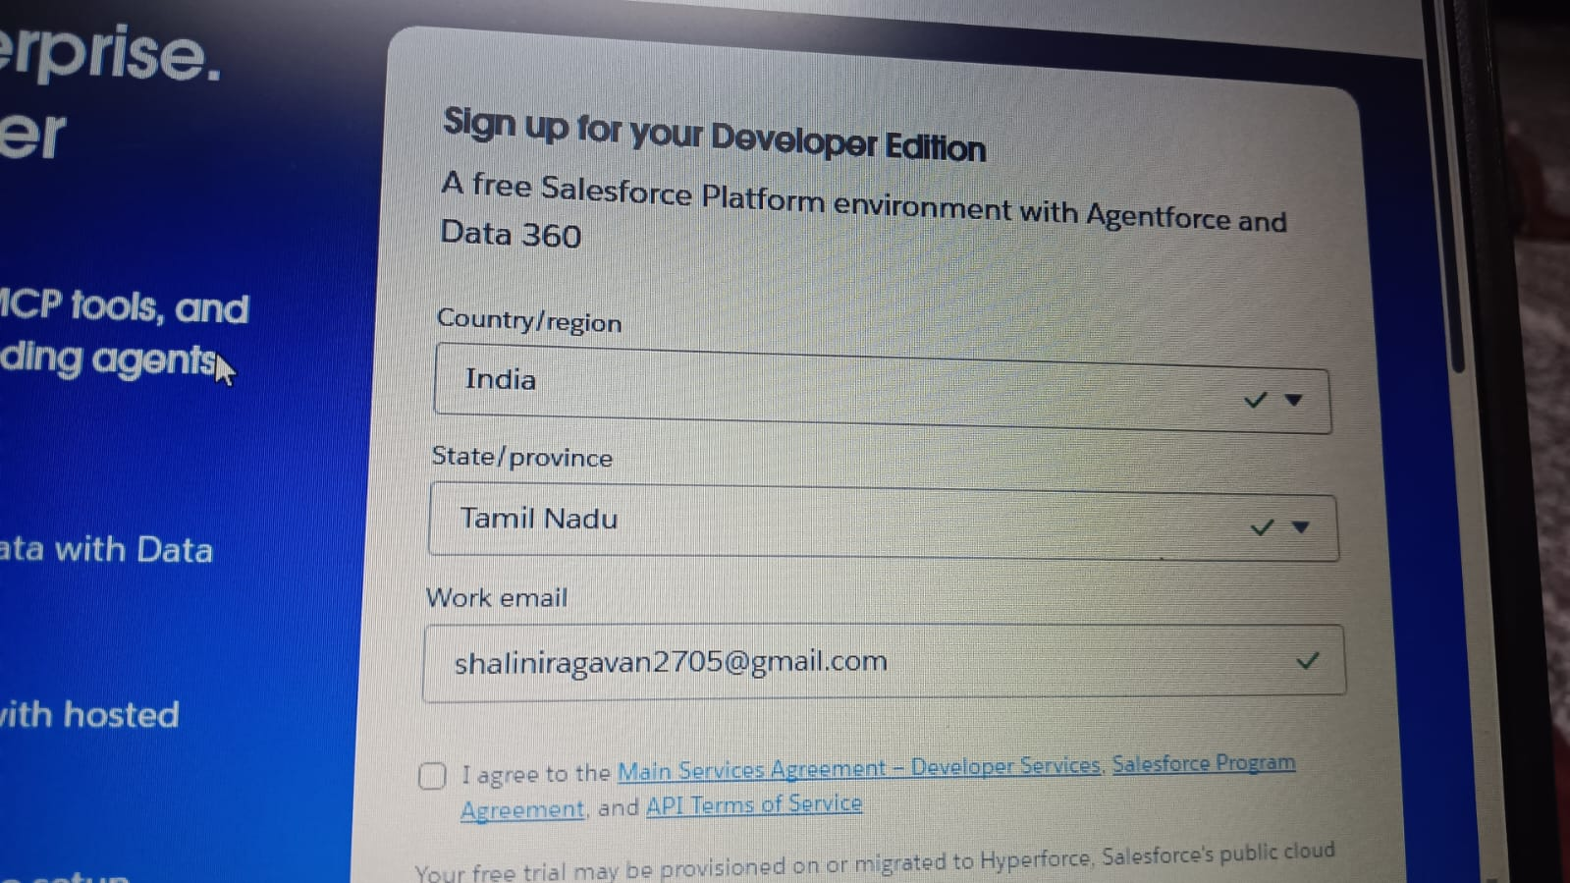

- First name & Last name
- Email
- Role : Developer
- Company : College or Company Name
- County : India
- Postal Code : pin code
- Username :username@organization.com

Activity 2: Account Activation :

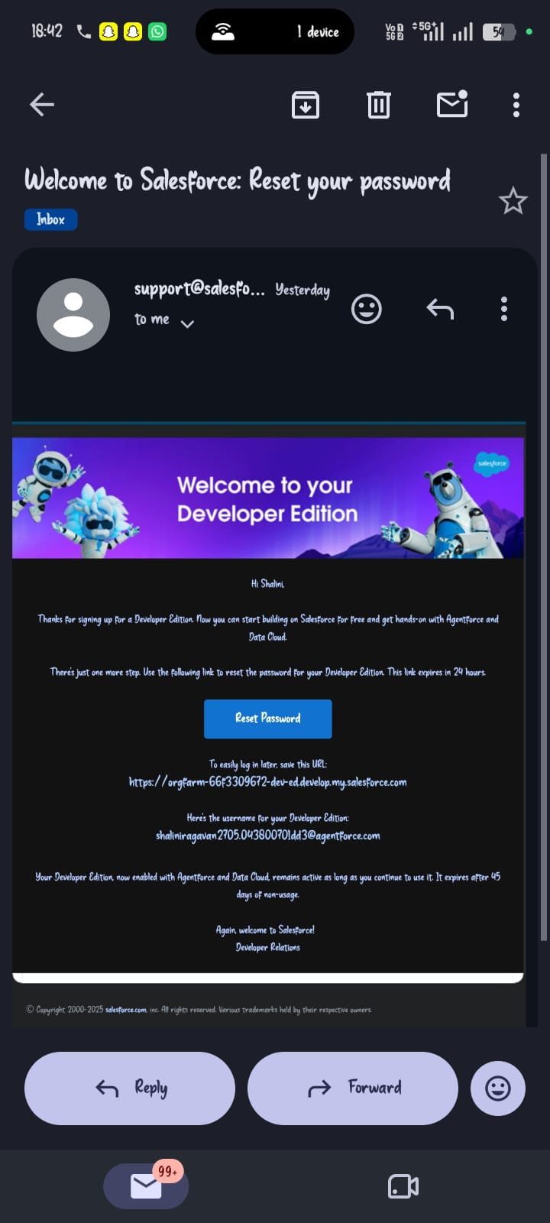
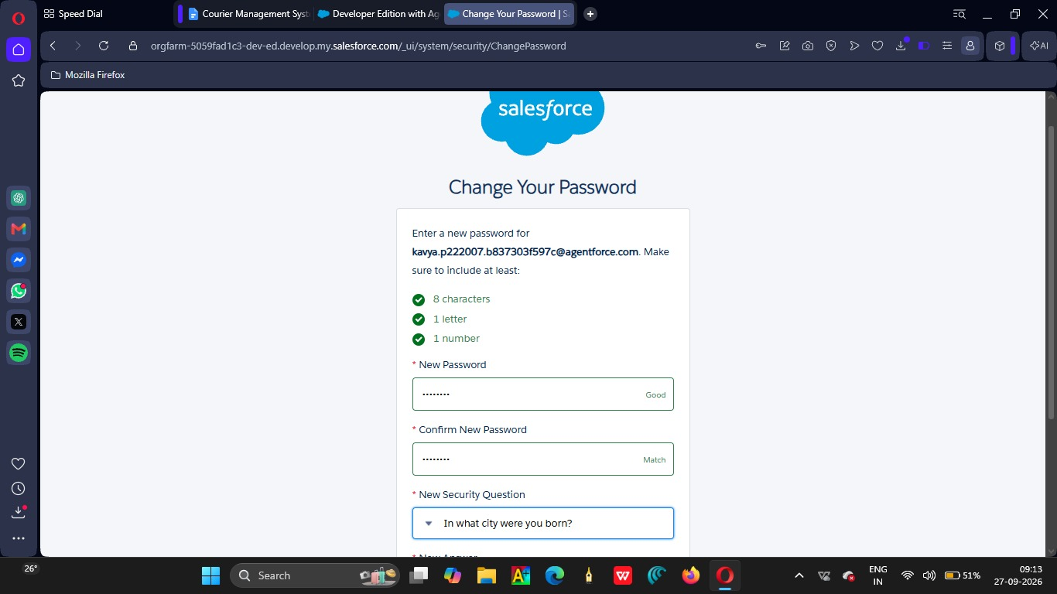

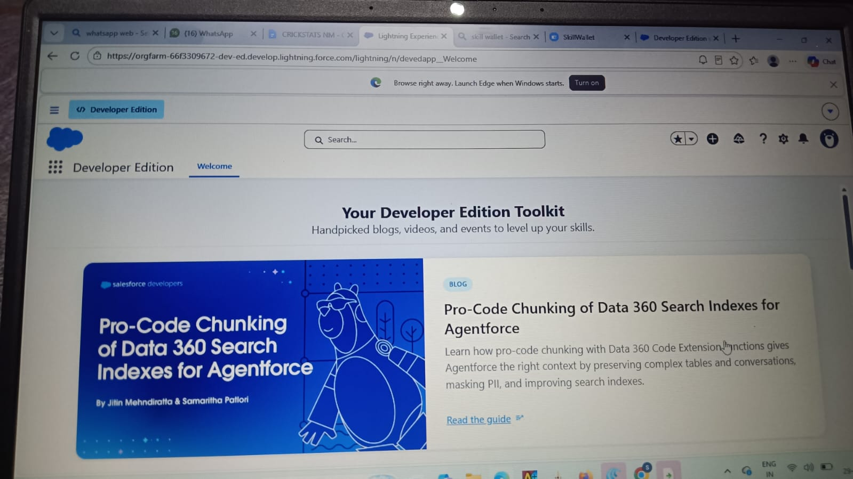

Milestone 2 - Object Creation

Activity 1 : Player Object

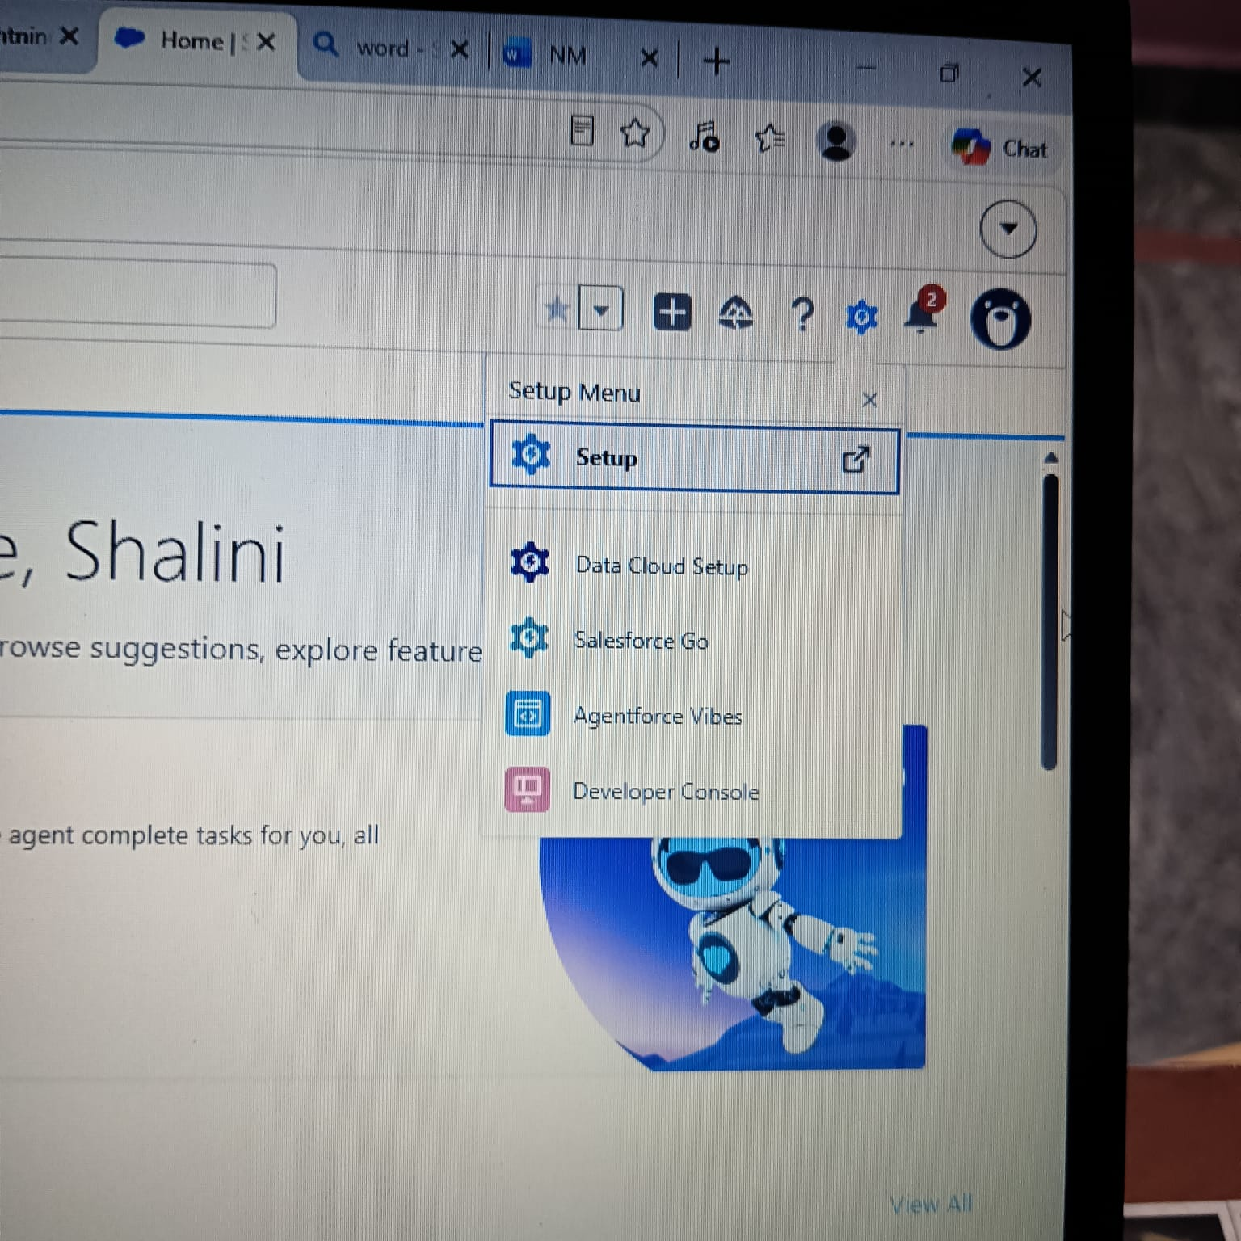

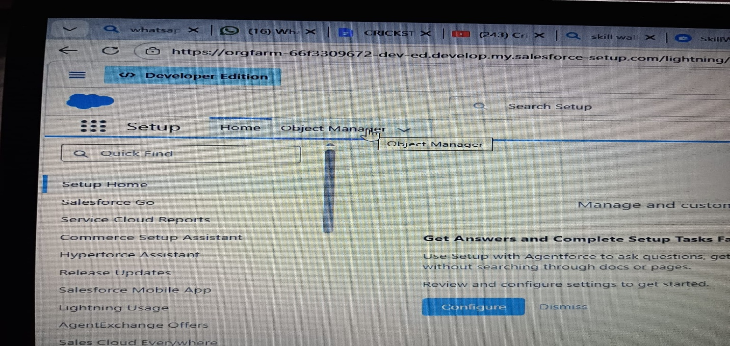
- 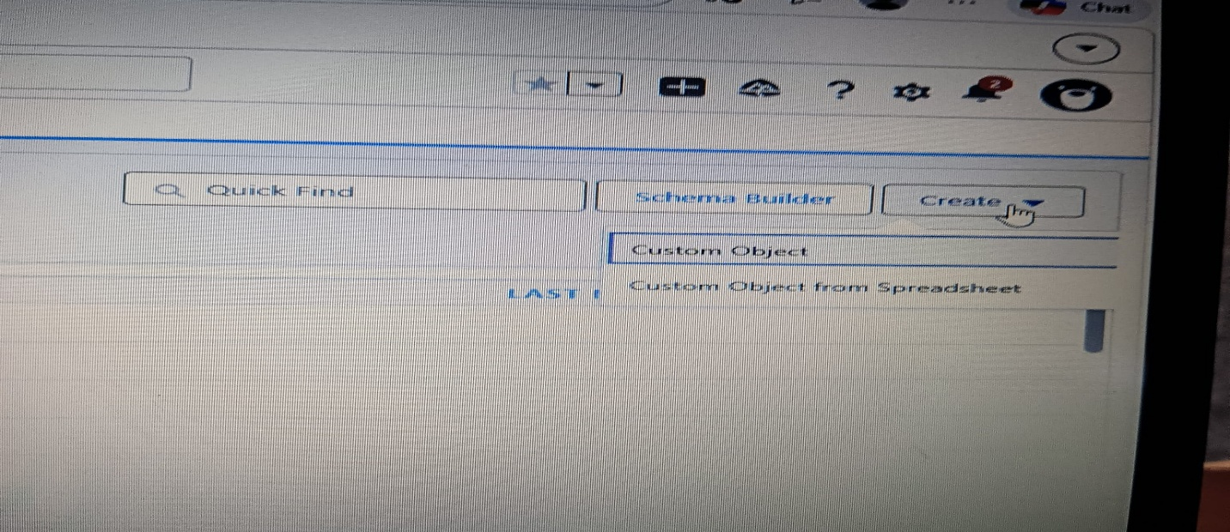

1.From the setup page → Click on Object Manager → Click on Create → Click on Custom Object.
- Label : Player
- Plural Label : Players
- Enter Record Name Label and Format
Record Name : Player Name
Data Type : Text
- In Optional features : check the boxes for Allow Reports | Allow Activities | Track Field History.
- Search Status : check the box for Allow Search.
- Save

Activity 2 : Match Performance Object

- From the setup page → Click on Object Manager → Click on Create → Click on Custom Object.
- Label : Match Performance
- Plural Label : Match Performances
- Enter Record Name Label and Format
Record Name : Customer Account Name
Data Type : Text
- In Optional features : check the boxes for Allow Reports | Allow Activities | Track Field History.
- Search Status : check the box for Allow Search.
- Save.

Milestone 3 - Tabs

Activity 1 : Custom tabs creation
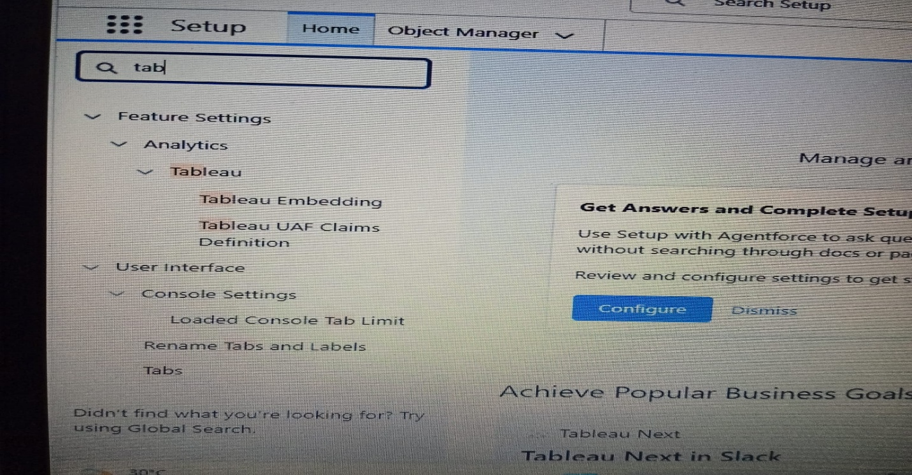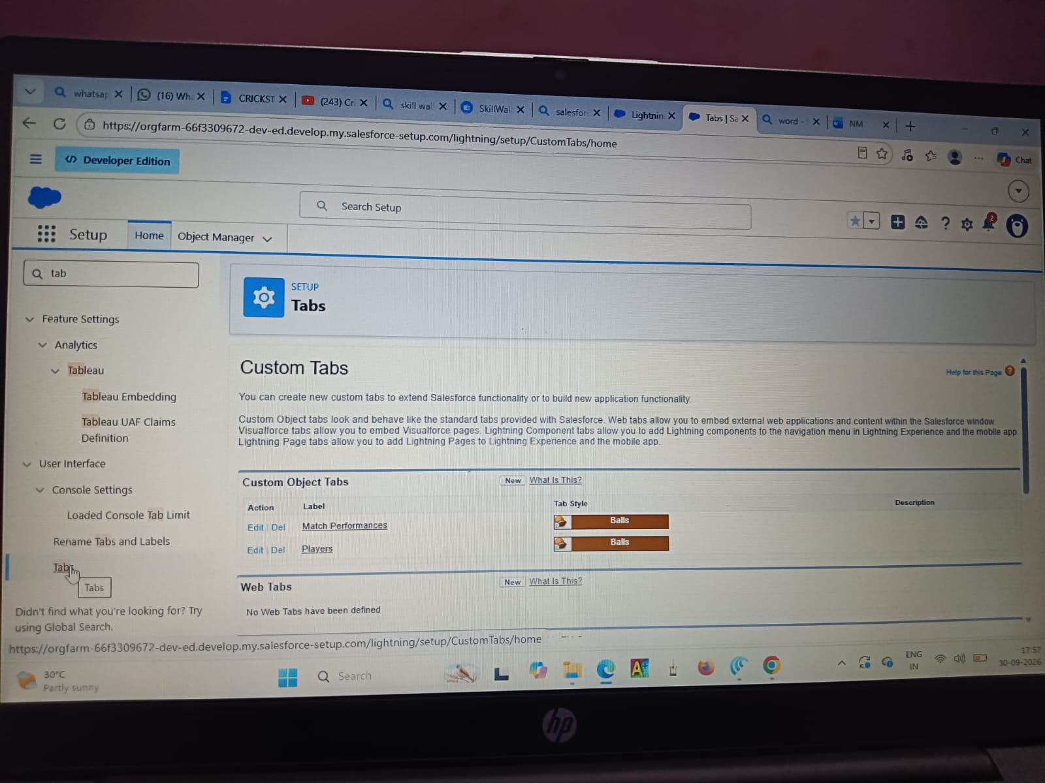

Milestone 4 - The Lightning App

Activity 1 : Create a lightning app
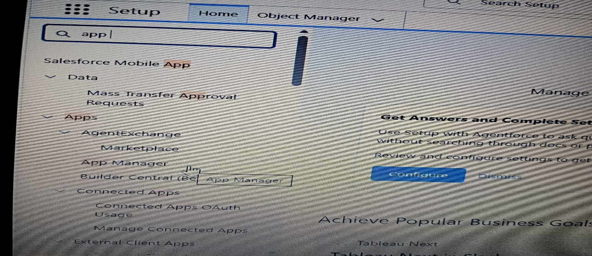
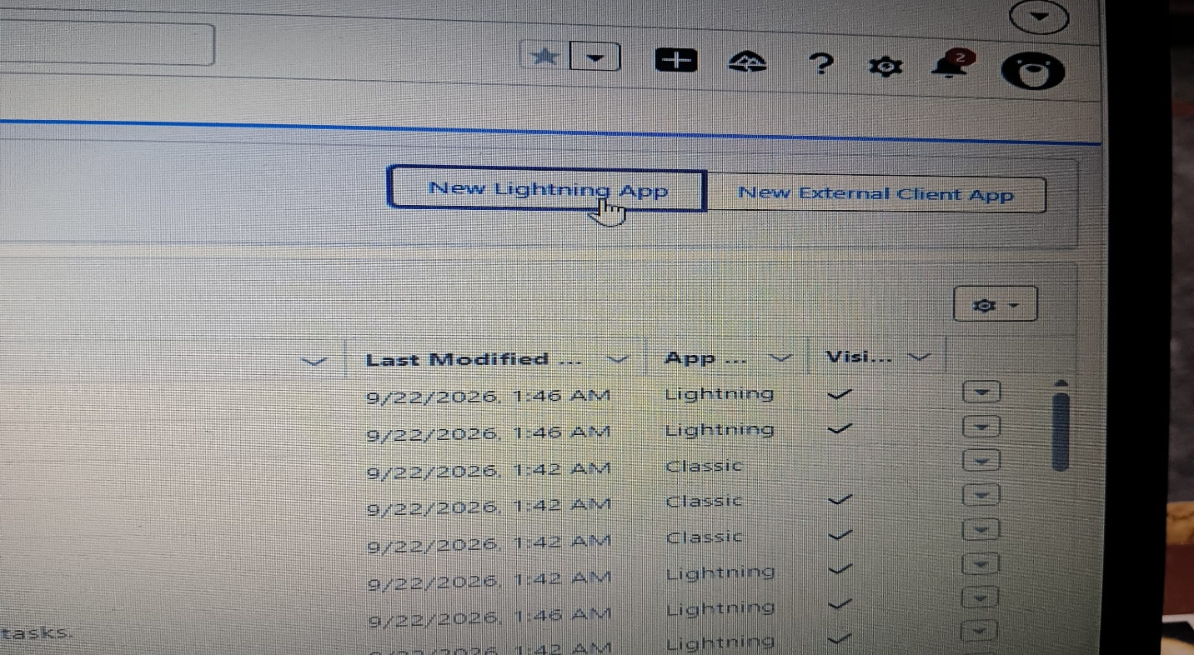

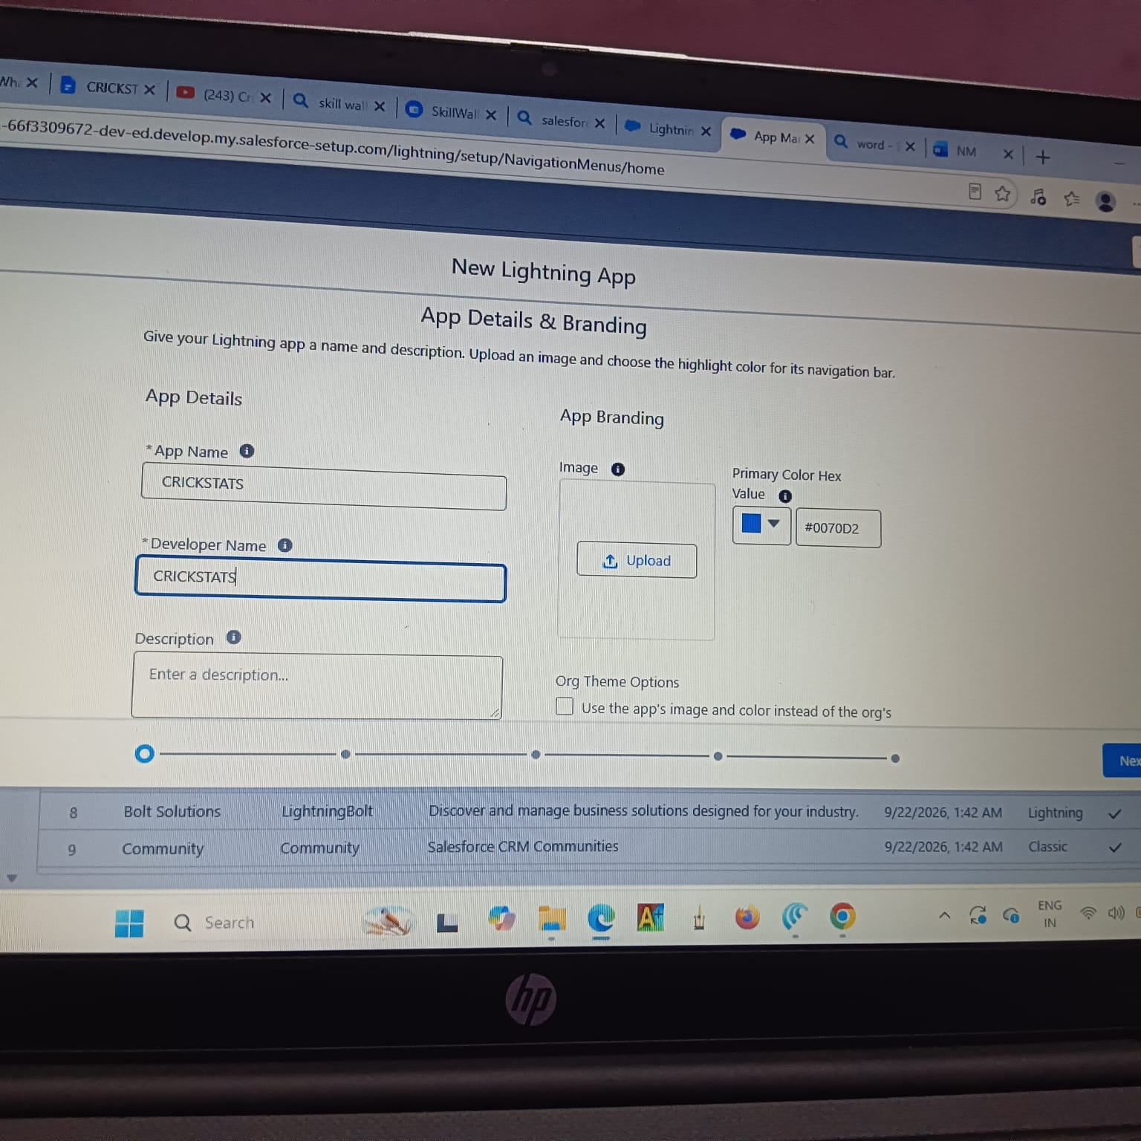

Milestone 5 : Fields & Relationships

Activity 1 : Create Custom fields for Player object
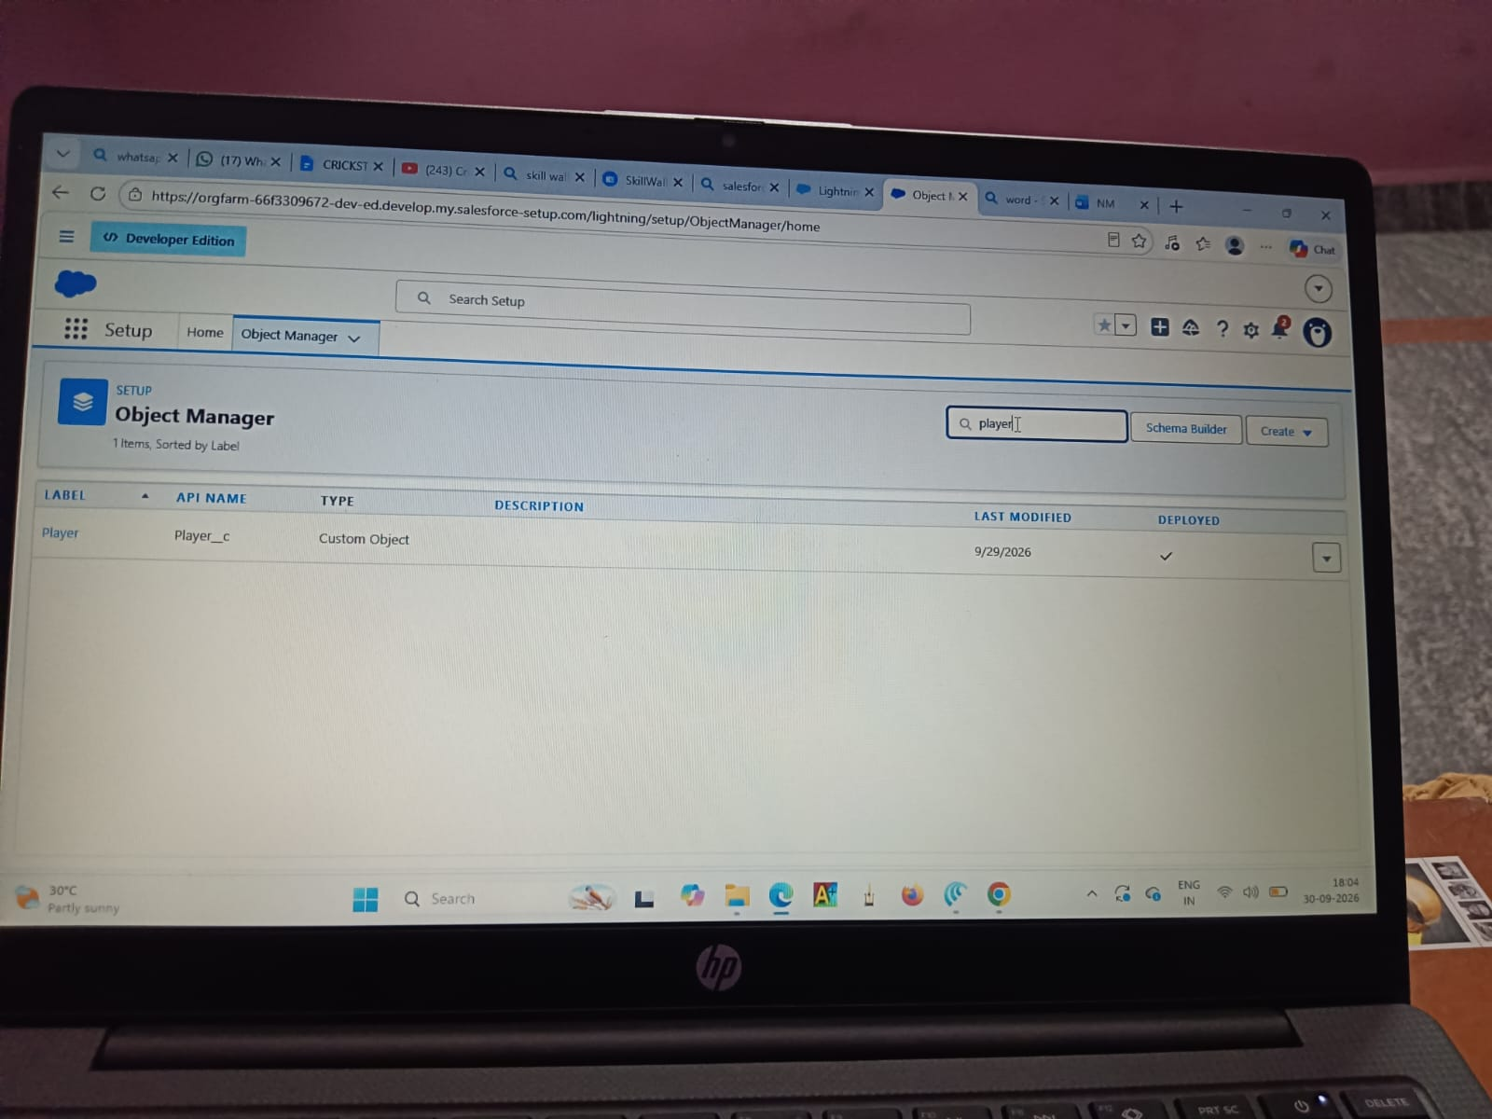

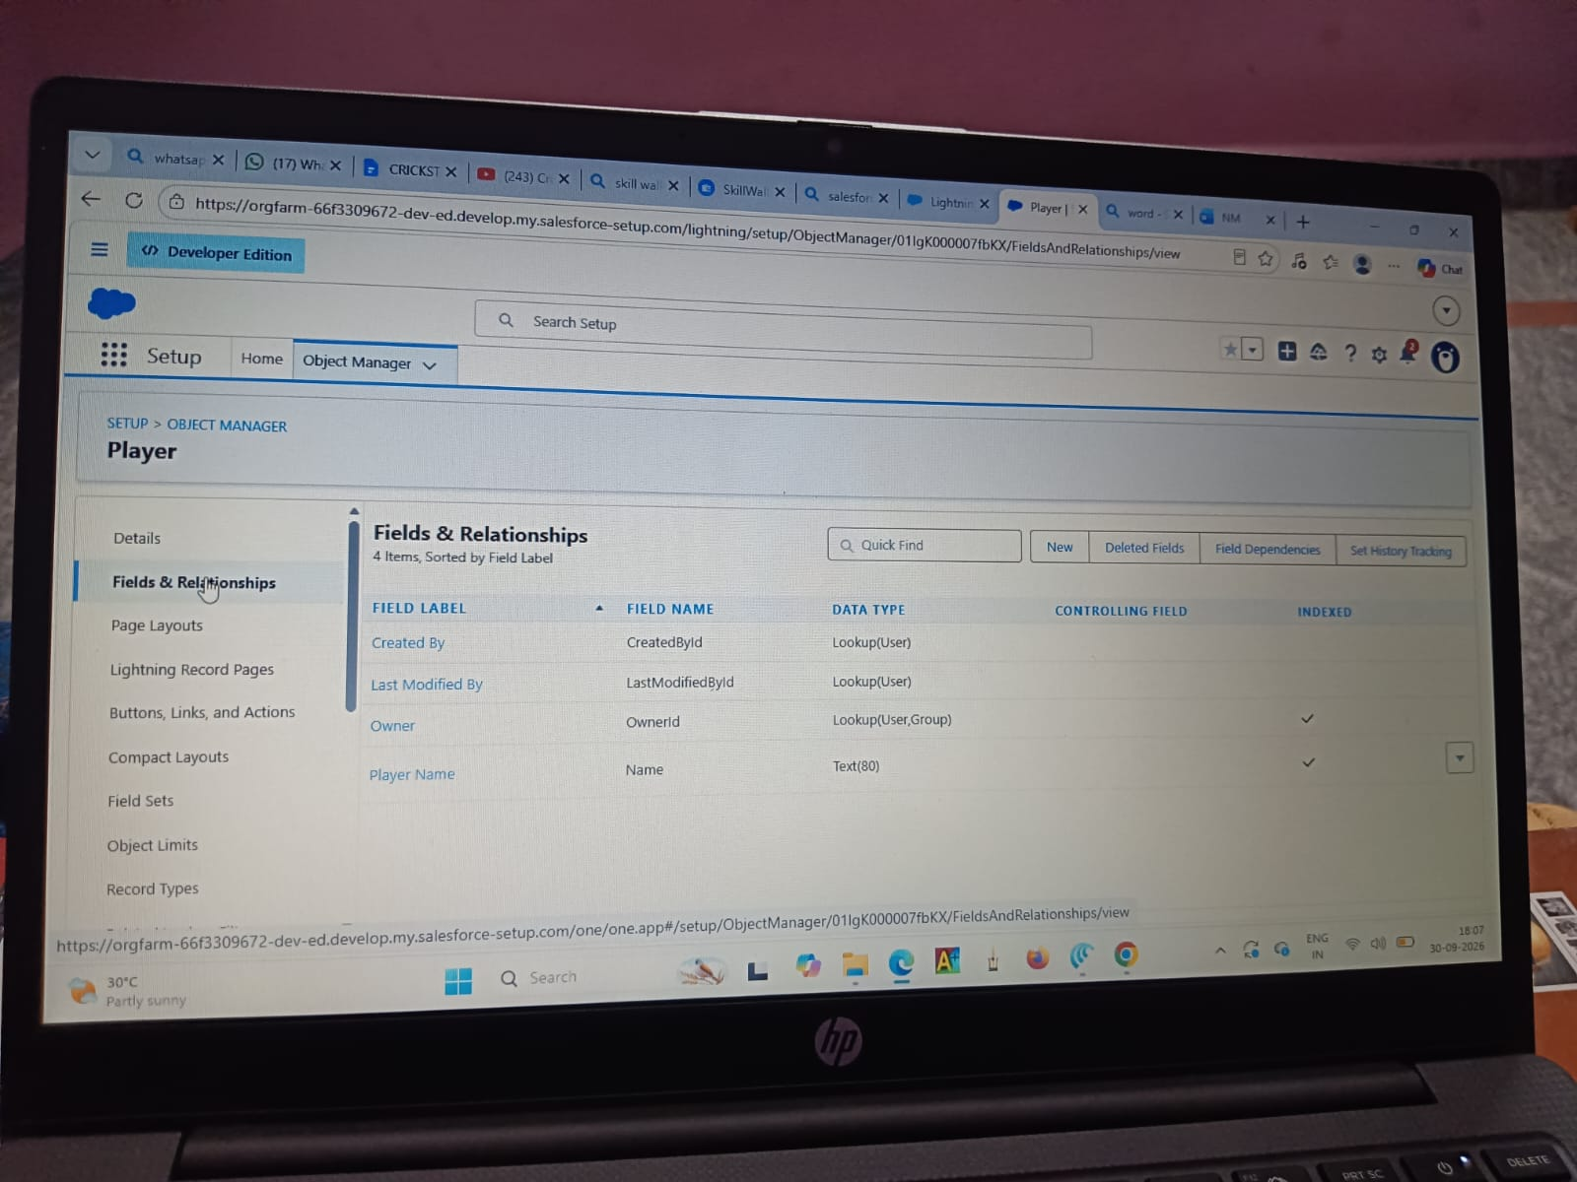Activity 2 : Create Custom fields for Match Performance object.

Milestone 6 : Roll-up Summary

Activity 1 : Create Roll-up Summary for Player object.

Milestone 7 : Flows

Activity 1 : Screen Flow
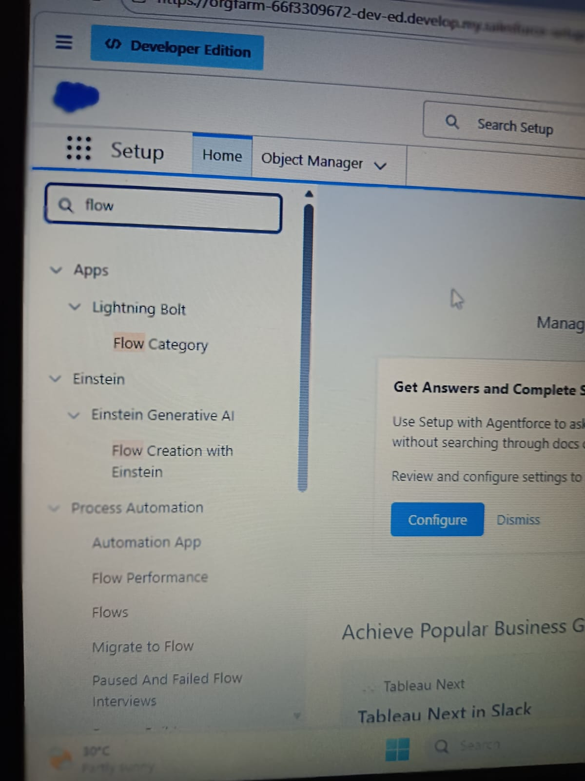

7. FUNCTIONAL & PERFORMANCE TESTING

During the testing phase, screenshots were captured from the Salesforce Lightning user interface to verify the correct functioning of all implemented features in the CRICKSTATS system. These include record creation for Player and Match Performance objects; validation rule checks for mandatory fields, score limits, and input constraints; verification of record type behavior for Domestic and International match categories; and flow execution for automatic updating of player statistics and data consistency. The functionality of roll-up summary fields was also tested to ensure accurate calculation of total runs, wickets, averages, and performance metrics.
In addition, system performance was evaluated by monitoring response time during data entry, report generation, and dashboard loading. The application was tested under multiple user interactions to ensure stable performance without delays. Screenshots of generated reports and interactive dashboards were documented to confirm accurate data visualization, real-time updates, and reliable performance tracking. These testing activities ensured that the CRICKSTATS platform met both functional and performance requirements and was ready for deployment.

8. ADVANTAGES & DISADVANTAGES

Advantages
- Centralized system
- Real-time analytics
- Secure platform
- Scalable design
- Reduced manual work

Disadvantages
- Requires Salesforce license
- Internet dependency
- Limited offline access

9. Conclusion:
CRICKSTATS successfully implements a cloud-based cricket performance tracking system using Salesforce. The system automates data management, improves reporting accuracy, and supports informed decision-making. The project demonstrates practical application of SDLC, Agile methodology, and CRM-based development.

10. FUTURE SCOPE
- Mobile application integration
- AI-based performance prediction
- Video analysis integration
- Player ranking system
- Public statistics portal
- Multi-league support

11. APPENDIX
- Salesforce Objects & Fields
- Manual match statistics
- Flow Configurations

Thank You

